Job Sheet

**Job No :** 5

**Job Title :** Project – Create Service Nodes to move TurtleSim robot forward and backward (Accountable Assignment)

Objective: Write a ROS Service (Client/Server) Nodes in Python

You are require to create a ROS Service Nodes in Python to move the turtleSim robot forward or back when input by the user. Create a custom service file which consist of distance, linear speed and whether robot is moving forward or not. Then, write a service client node to get the inputs of the distance, speed and whether if robot is moving forward or not from the user and a service server node to move the turtleSim robot based on the stated speed, distance and forward or reverse direction. This can be done by publishing to the command velocity topic of the turtleSim. The current position of the turtleSim robot can be obtained by subscribing to the pose topic of the turtleSim robot.

Hint*

Import math

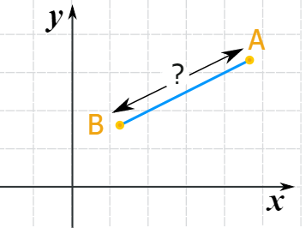

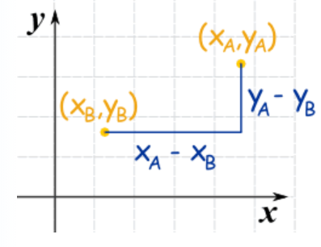

distance = 

Assessment criteria should include:

* Create a ROS Package
* **Create a customize ROS Service file**
* Create a Request/Response Message
* Write ROS Service (Client/Server) in Python

**Major Tools, Equipment and Software**

**2 students in a group.**

|  |  |  |
| --- | --- | --- |
| **S/N** | **Descriptions** | **Qty** |
| 1 |  |  |
| 2 |  |  |
| 3 |  |  |

**Procedures**:

1. Create a new ROS Package and name it “ros_assignment” in catkin workspace i.e., **catkin_ws/src**
2. **Include the following dependencies:**
   1. std_msgs
   2. rospy
   3. roscpp
3. Compile the Catkin Workspace

|  |  |  |  |  |
| --- | --- | --- | --- | --- |
| **For Teacher Marking Only** | | | | |
| **Create a ROS Package** | | | **successfully / unsuccessfully \*** | |
|  | | | | |
| Name / Signature of teacher : | |  | |  |
|  | |  | |  |
| Note : | If the hardware and the software steps are incorrect, teacher will provide assistance to the candidate in order to proceed. | | | |
|  | |  | |  |
| *\* Delete as applicable* | | | | |

1. Create a service folder in catkin_ws under “srv”
2. Create a new service file and name is: “Move.srv”

float32 distance

float32 speed

bool flag

---

1. Configure CMakeLists.txt and package.xml
2. Compile catkin workspace
3. Show the new service file is properly created in command prompt to your instructor

|  |  |  |  |  |
| --- | --- | --- | --- | --- |
| **For Teacher Marking Only** | | | | |
| 1. **Create a customize ROS Service file** 2. **Create a Request/Response Message** | | | **successfully / unsuccessfully \*** | |
|  | | | | |
| Name / Signature of teacher : | |  | |  |
|  | |  | |  |
| Note : | If the hardware and the software steps are incorrect, teacher will provide assistance to the candidate in order to proceed. | | | |
|  | |  | |  |
| *\* Delete as applicable* | | | | |

1. Write ROS Service (Client/Server) in Python

9. Open the python demo files: ‘move_client_assignment.py’ and ‘move_server_assignment.py’ using Visual Studio Code.

10. Fill up the missing blanks in the scripts

* 1. Move_client.py

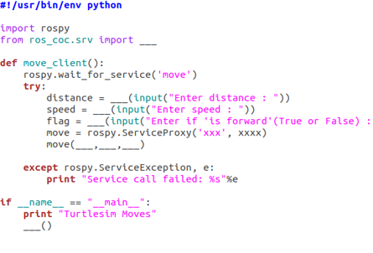

* 1. Move_server.py

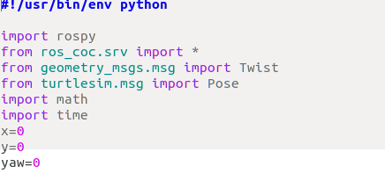

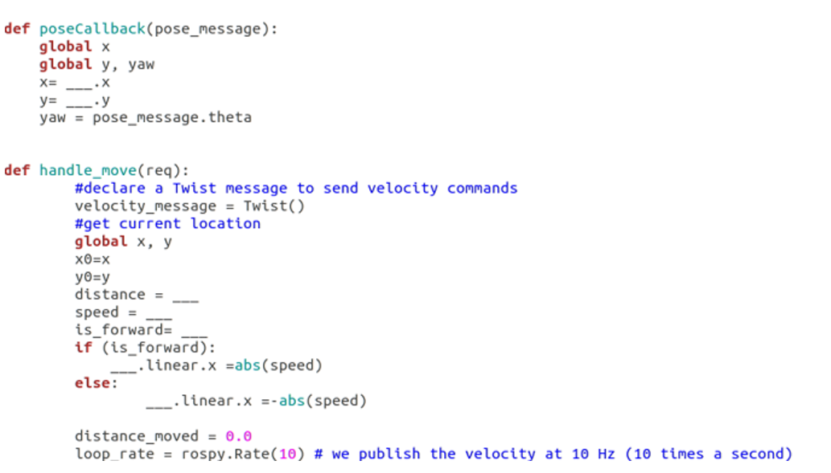

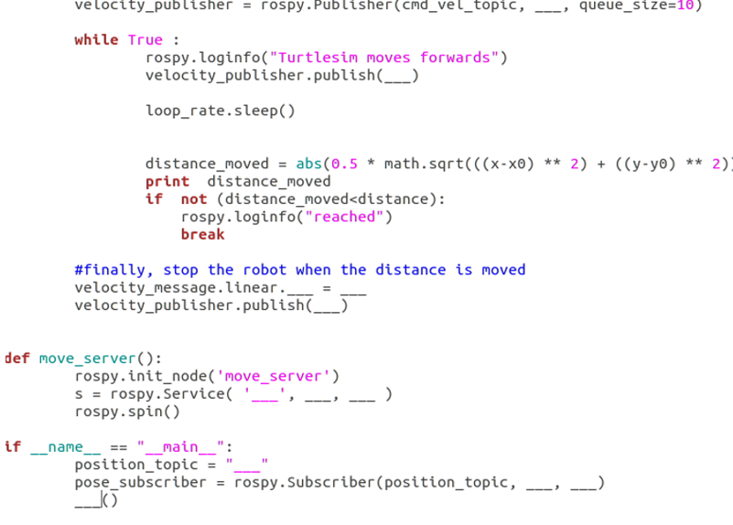

10. Run the scripts

11. Show the output to the instructor by input distance = 1.0, speed = 1.0 and is_forward = True

|  |  |  |  |  |
| --- | --- | --- | --- | --- |
| **For Teacher Marking Only** | | | | |
| **Write ROS Service (Client/Server) in Python** | | | **successfully / unsuccessfully \*** | |
|  | | | | |
| Name / Signature of teacher : | |  | |  |
|  | |  | |  |
| Note : | If the hardware and the software steps are incorrect, teacher will provide assistance to the candidate in order to proceed. | | | |
|  | |  | |  |
| *\* Delete as applicable* | | | | |